Assignment – 13
Subqueries Assignment Commands

1. Write a query to find the name (first_name, last_name) and the salary of the employees who have a higher salary than the employee whose last_name='Bull'.
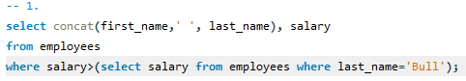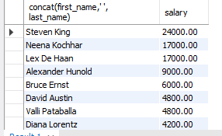
2. Write a query to find the name (first_name, last_name) of all employees who works in the IT department.
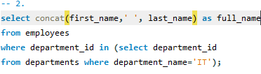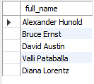
3. Write a query to find the name (first_name, last_name) of the employees who have a manager and worked in a USA based department.
Hint : Write single-row and multiple-row subqueries
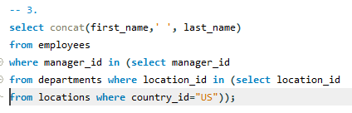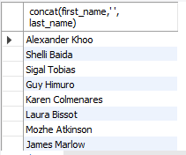
4. Write a query to find the name (first_name, last_name) of the employees who are managers.
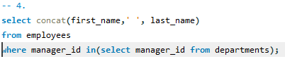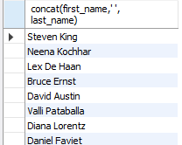
5. Write a query to find the name (first_name, last_name), and salary of the employees whose salary is greater than the average salary.
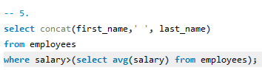
6. Write a query to find the name (first_name, last_name), and salary of the employees whose salary is equal to the minimum salary for their job grade.
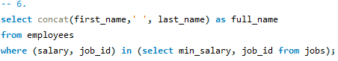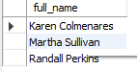
7. Write a query to find the name (first_name, last_name), and salary of the employees who earns more than the average salary and works in any of the IT departments.
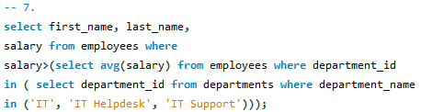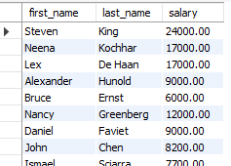
8. Write a query to find the name (first_name, last_name), and salary of the employees who earns more than the earning of Mr. Bell.
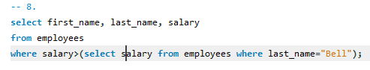
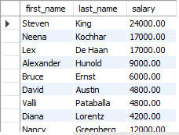
9. Write a query to find the name (first_name, last_name), and salary of the employees who earn the same salary as the minimum salary for all departments.
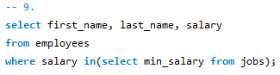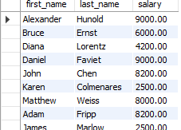
10. Write a query to find the name (first_name, last_name), and salary of the employees whose salary is greater than the average salary of all departments.
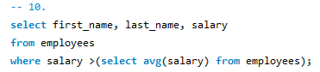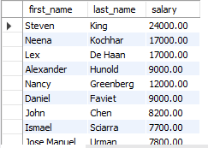
11. Write a query to find the name (first_name, last_name) and salary of the employees who earn a salary that is higher than the salary of all the Shipping Clerk (JOB_ID = 'SH_CLERK'). Sort the results of the salary of the lowest to highest.
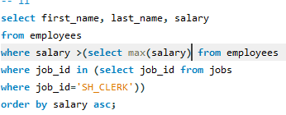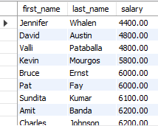

12. Write a query to find the name (first_name, last_name) of the employees who are not supervisors.
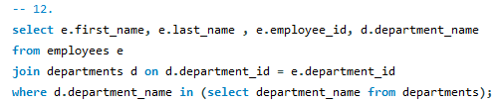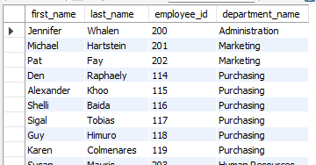
13. Write a query to display the employee ID, first name, last name, and department names of all employees.
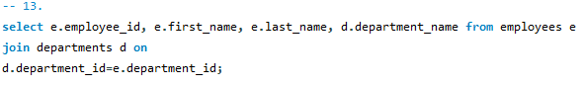
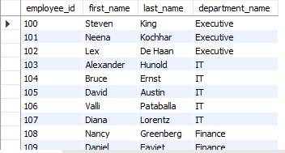
14. Write a query to display the employee ID, first name, last name, salary of all employees whose salary is above average for their departments.
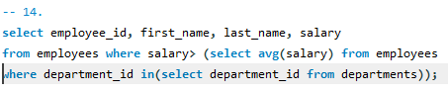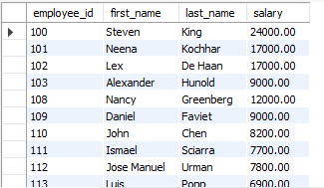
15. Write a query to fetch even numbered records from the employees table.
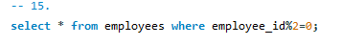
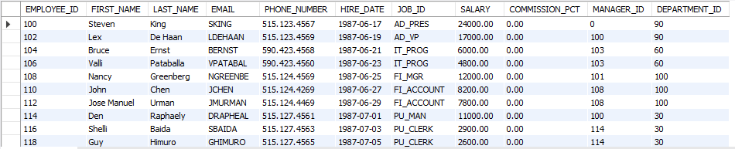
16. Write a query to find the 5th maximum salary in the employees table.
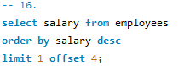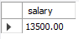
17. Write a query to find the 4th minimum salary in the employees table.
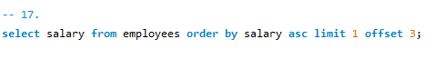
18. Write a query to select the last 10 records from a table.
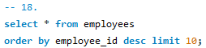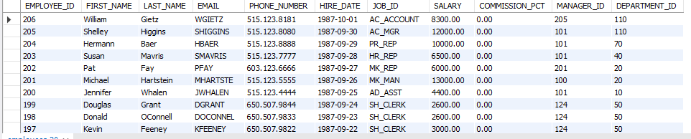
19. Write a query to list the department ID and name of all the departments where no employee is working.
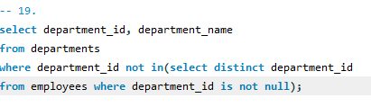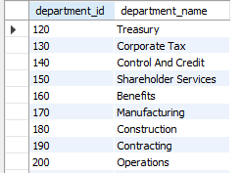
20. Write a query to get 3 maximum salaries.
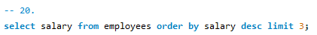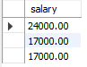
21. Write a query to get 3 minimum salaries.
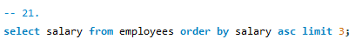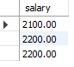
22. Write a query to get nth max salaries of employees.
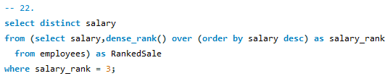

23. Write a query that returns all employees who have a salary greater than the average salary of their department.
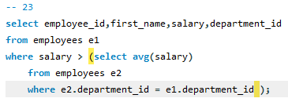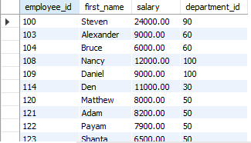
24. Write a query that returns the names of all departments that have more than 10 employees.
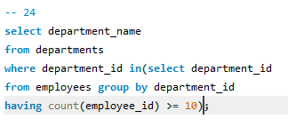
25. Write a query that returns the names of all employees who work in departments that have a total salary greater than $1,000,000.
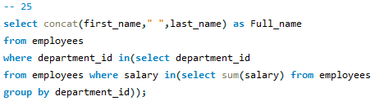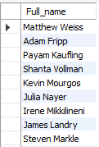
26. Write a query that returns the average salary of all employees who have been with the company for less than 3 years.
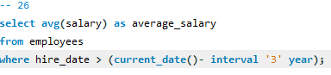
27. Write a query that returns the names of all employees who have the same manager as the employee with ID 123.
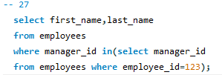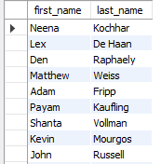
28. Write a query that returns the department name and average salary of the department with the highest average salary.
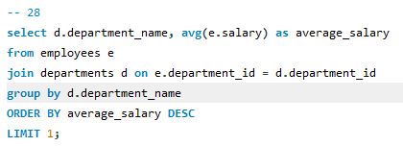
29. Write a query that returns the names of all employees who have a salary greater than the highest salary in the sales department.
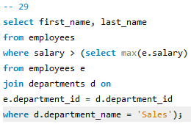
30. Write a query that returns the names of all employees who have a manager with a salary greater than $100,000.
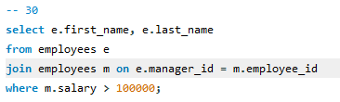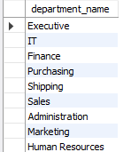
31. Write a query that returns the names of all departments that have at least one employee who has been with the company for more than 5 years
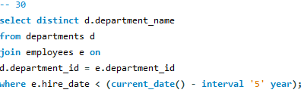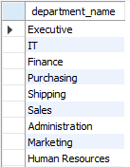
32. Write a query that returns the name and salary of the employee with the second-highest salary in the company.



